## *The Phototactic Matter Experiment*

## horizontal line

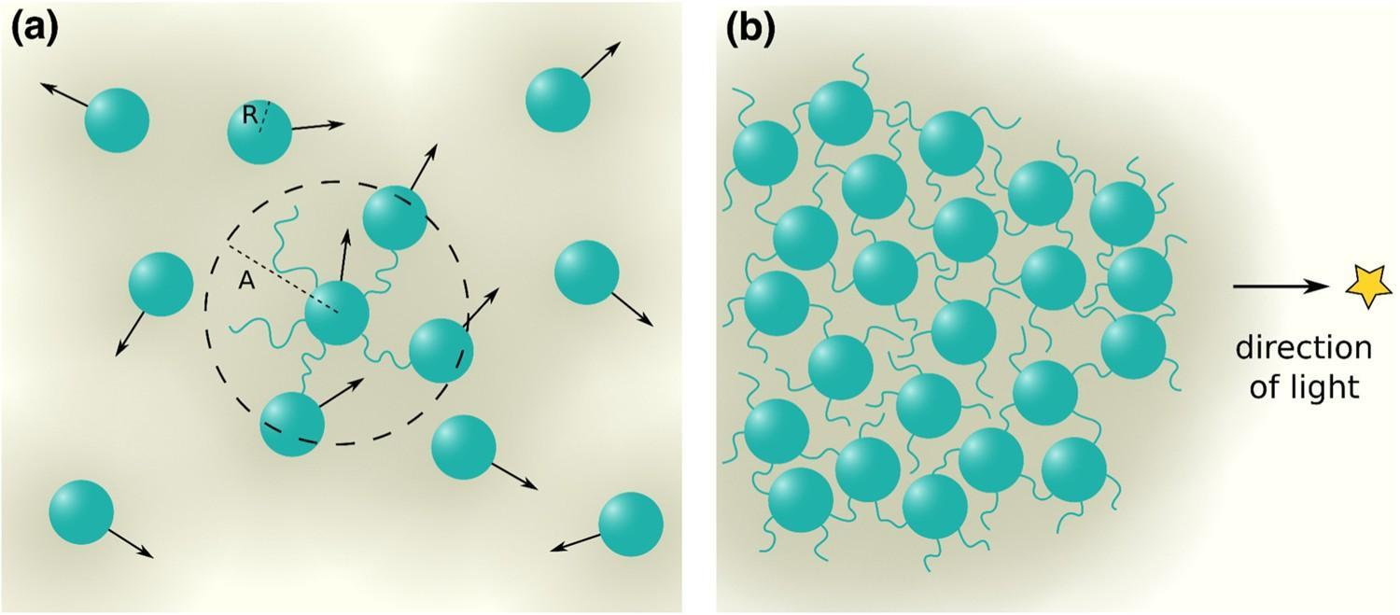

*Image source: Nature. (https://images.app.goo.gl/LiitJhDALM5uTiWE7)*

Investigation of Phototactic Behavior in Particulate Matter: Exploring Photon-Induced Particle Movement

09.06.2024, *Last* *Revision 09.25.2024.*

______________________

James M. Moore

Qualia Man

134 NE 20th St.

Oak Island, NC 28465

_______________________

# Preamble

The premise for this experiment was constructed based on an observation of interaction between a 20-volt DeWalt flashlight and fiberglass dust particles. In a room with still air, the fiberglass particles were aerosolized and upon exposure to light, appeared to be physically attracted to the beam. This phenomenon, observed consistently for roughly an hour, was filmed on a cell phone camera. That video is the evidence for inorganic phototaxis. The experiment will confirm or deny the validity of the assumption that some form of inorganic matter is attracted to light, or dismiss it as an optical illusion based on the frame of reference.

# Hypothesis

Tiny particles are attracted to a light source due to one or a combination of photophoresis, electrostatic attraction, or convection currents.

# Objectives

1. To determine if small particles are attracted to a light source.
2. To determine why these particles are attracted to the light source.

# Materials

- Various light sources (LED, incandescent, laser pointer, etc.)

- Different types of particulate matter (fiberglass, common household dust, talcum powder, etc.)

- Dark room or box to control light conditions

- Camera or smartphone for recording

- Electrostatic charge generator (optional for testing electrostatic effects)

- Temperature and humidity meter

- Digital microscope or magnifying glass for particle observation

- Non-conductive surfaces to place particles on

- Large Vacuum Chamber

# Procedure

## Control Setup

- Set up a dark environment to minimize external light interference.

- Ensure the room is as still as possible to reduce air currents not caused by the experiment.

- Document baseline conditions (temperature, humidity).

## Particle Selection

- Begin with suspected material (like fiberglass if possible).

- Also test with other known particles (e.g., talc, flour, fine sand) for comparison.

## Light Source Variation

- Use different light sources to see if intensity, spectrum, or type (LED vs. incandescent) affects the phenomenon.

## Experiment Steps

Step 1: Particle Distribution: Place a small, known amount of particles on a non-conductive flat surface in the vacuum chamber.

Step 2: Light Exposure: Shine the light perpendicular to the surface from a fixed distance.

Step 3: Observation: Record the behavior of the particles using a camera set to capture slow-motion if possible to observe fine movements.

Step 4: Charge Variation: Optionally, use an electrostatic generator to give the flashlight lens or the particles a charge to see if this enhances or changes the effect.

## Data Collection

- Record time taken for noticeable particle movement towards the light.

- Note any patterns or directions of movement relative to the light source.

- Document changes in behavior with different particles and light sources.

## Analysis

- Compare videos to analyze particle movement speed, direction, and any attraction or repulsion observed.

- Evaluate if movement correlates with thermal changes from the light (possible photophoresis).

- Check if particles with different properties (size, shape, material) behave differently.

## Control for air currents

- Use a transparent barrier to block air currents while allowing light to pass, to see if particles still move towards the light.

- Disturb the particles to aerosolize them, but keep air currents to a minimum.

## Repetition

- Repeat the experiment multiple times for each change to the set of conditions, conserving reproducibility.

- Change one variable at a time (e.g., particle type, light source, distance from light) to isolate effects.

## Conclusions

- Analyze all collected data to see if there's a consistent attraction to the light source.

- Determine if the effect can be attributed to photophoresis, electrostatic forces, or another phenomenon.

*Examine the particles with microscopy before and after the experiment to see if there are any physical changes due to the light exposure.*

# Potential Additional Steps:

## Microscopic Analysis

Examine the particles under a microscope before and after the experiment to see if there are any physical changes due to the light exposure.

## Spectrometry

Use spectrometry to analyze the composition of particles attracted to or repelled by the light, which might give clues about why certain materials react this way.

*By systematically varying conditions and observing results, you can begin to identify what material properties and environmental conditions contribute to the observed effect.*

*Copyright 2024 James Moore, Qualia Man.*